
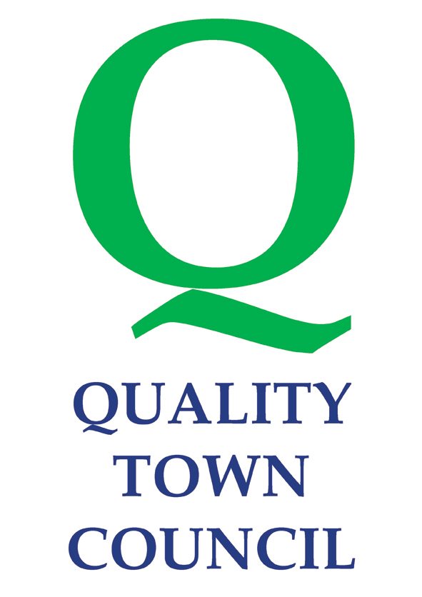
Littlehampton Town Council- September 29th 2025

NOTICE OF CONCLUSION OF ANNUAL AUDIT

ACCOUNTS FOR THE YEAR ENDED 31 MARCH 2025
Accounts and Audit Regulations 2015

- The audit of accounts for Littlehampton Town Council for the year ended 31 March 2025 have been completed and the accounts have been published.

- The Annual Return is available for inspection by any local government elector in the area of Littlehampton Town Council on application to:

Laura Chrysostomou
Town Clerk
Manor House, Church Street
Littlehampton
BN17 5EW
ltc@littlehampton-tc.gov.uk

Between the hours of 9am to 16:00pm Monday to Friday

- Copies will be provided to any person on request

Announcement made by:
Laura Chrysostomou, Town Clerk
Date of Announcement: 29th September 2025

